Hospital Data Analysis – EDA

Univariate analysis :

DRG Code distribution :
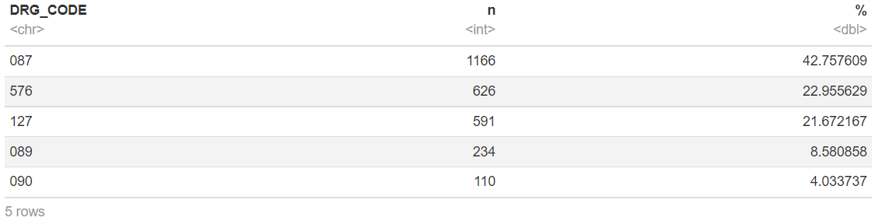
- Most of the admissions mainly correspond to a DRG 087 : «Pulmonary edema and respiratory failure» (largely), 576: «Sepsis without medical ventilation» or 127: «Heart failure and shock»;
- Those which correspond to a DRG 089 «Pneumonia and pleuritis with complications » and 090 «Pneumonia and pleuritis >17 year old » each constitute smaller proportions.

Ward Admission distribution (WARD_ADMISSION) :
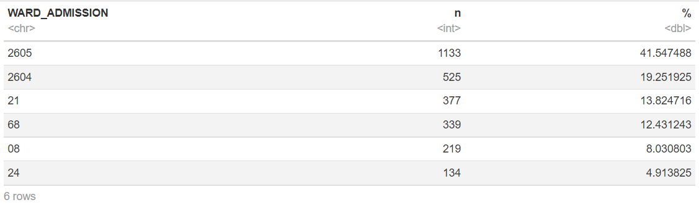
- Les admissions en Ward « General Medicine » sont majoritaires : une grande partie en Ward 2605 : « General Medicine 2 » et moins conséquente en Ward 2604 : « General Medicine 1 ».
- Admissions in Ward « General Medicine » are in majority : a large part in Ward 2605 : « General Medicine 2 » and a less significant one in Ward 2604 : « General Medicine 1 »;
- Those within the Wards 21 : « Geriatrics », 68 : «Respiratory Medicine », 08 : « Cardiology » and Ward 24 : «Infection and Immunology» each constitute smaller proportions.

Ward Discharge distribution (WARD_DISCHARG)
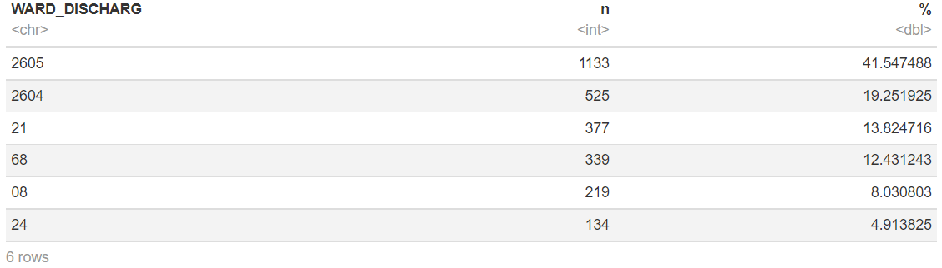
- Discharges from Wards « General Medicine » are in majority: a large part in Ward 2605 : « General Medicine 2 » and a less significant one in Ward 2604 : « General Medicine 1 »;
- Those in Wards 21 : « Geriatrics », 68 : «Respiratory Medicine », 08 : « Cardiology » and Ward 24 : «Infection and Immunology» each constitute smaller proportions.

Number of deaths distribution within/outside Hospitals (DEATH_INHOSP)
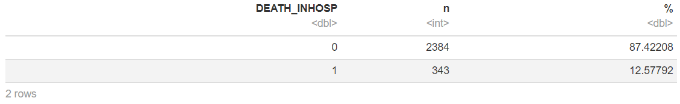
- Deaths occur mainly (in a very large part) outside hospitals, those which occur within hospital settings constitute only a small proportion.

Costs distribution per Ward (COST_DAY_WARD)
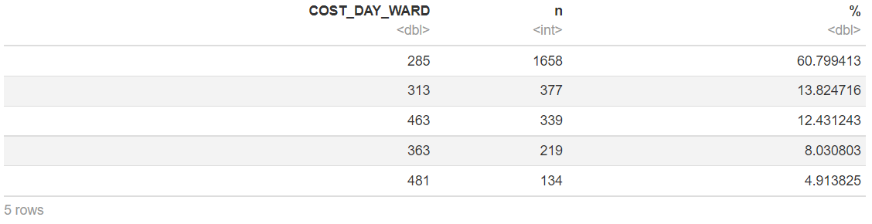
- Daily hospital costs valued at €285 constitute the majority;
- Those valued at €313, €463, €363 and at €481 each constitute smaller proportions.

Severity distribution (SEVERITY)
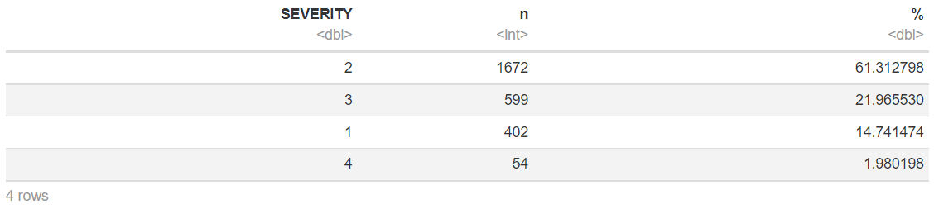
- Admissions of patients with a level 2 of severity risk : « Moderate » are clearly in majority;
- Then follow the admissions with the levels 3 « Major» and 1 : « Minor »;
- Those with a level 4 of severity risk « Severe » are poorly numerous.

Risk Death distribution within/outside Hospitals (RISKDEATH)
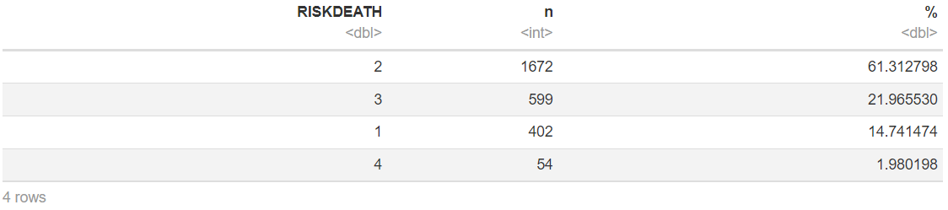
- Admissions of patients with a level 2: « Moderate » of Risk Death are clearly in majority;
- Then follow the admissions with a level 3: « High » and 1 : « Low » of Risk Death;
- Those with a level 4: « Extreme » of Risk Death are poorly numerous.

Sex distribution (SEX)
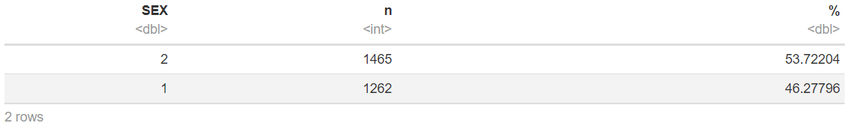
- Women admitted to hospitals outnumber Men.

Number of surgery distribution (N_INTERVENTION)
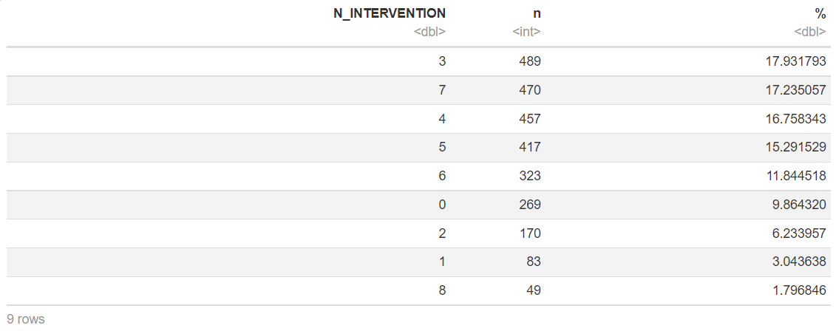
- The vast majority of admissions requires between 3 to 7 surgeries;
- Admissions that don’t require any surgery constitute a proportion relatively interesting compared to those which require only 1 to 2 surgeries;
- Admissions requiring up to 8 surgeries are poorly numerous;

Distribution w.r.t the Charlson Comirbidity Index (CCI)
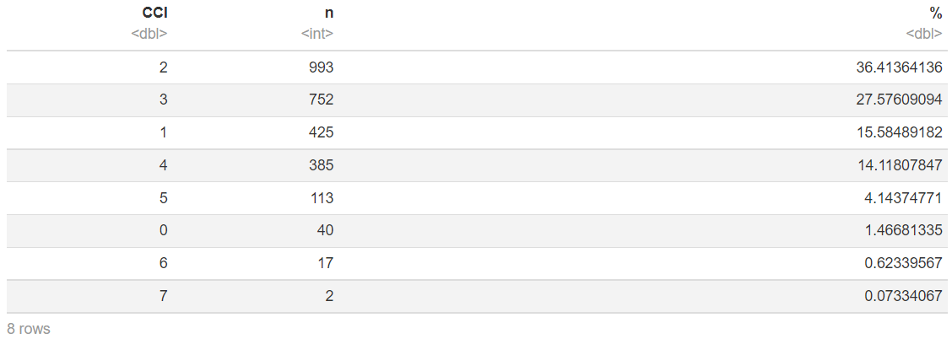
- The vast majority of admissions corresponds to an index of CCI generally starting from 1 to 4, with a particular interest on the scores 2 and 3, which together constitute clearly more than the half of the admissions;
- Although they are less numerous, admissions that correspond to a CCI score equals to 5 seem to be relatively significant in terms of proportions;
- In particular, admissions that correspond to an index of CCI equals to 0 are relatively poorly numerous;
- Those which correspond to an index greater than or equal to 6 can be considered as being poorly numerous, even rare for those with the index 7.

The Lengths of Stay in Hospital (LOS)

Min. 1st Qu. Median Mean 3rd Qu. Max.
1.000 5.000 7.000 8.666 11.000 72.000
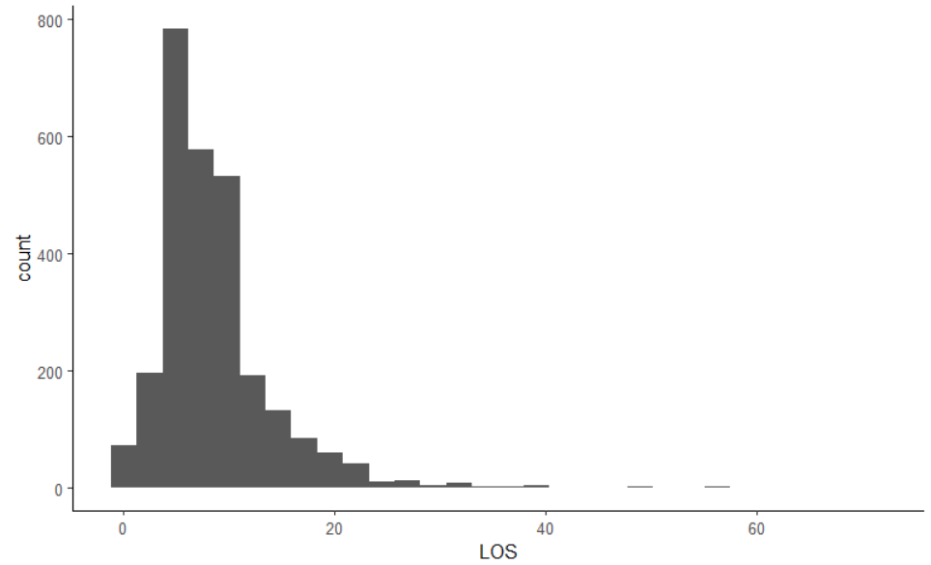
- The peak that corresponds to the LOS is clearly situated between 5 and 10 days (histogram), whereas the data dispersion extends from (around) 1 to 75 days;
- The minimum value of LOS is 1 day, whereas the maximum one is 72 days : a significant difference (71 days) can be observed between the two values, that of the maximum LOS is very high;
- The 1st Quartile of LOS values is 5 days, in other words, 25% of the LOS values are lower than or equal to 5 days;
- The 2nd Quartile (Median) of LOS values is 7 days, in other words, 50% of the LOS values are lower than or equal to 7 days, and the other 50% are greater than or equal to 7 days;
- The 3rd Quartile of LOS values is 11 days, in other words, 75% of the LOS values are lower than or equal to 11 days;
- The Average of LOS values is 8,666 days (outliers might thus be present among the corresponding data), it is greater than the Median which is 7 days: We therefore have an asymmetry to the right here.

The total costs (TOTAL_COST)
Min. 1st Qu. Median Mean 3rd Qu. Max.
285 1738 2508 3038 3718 27985
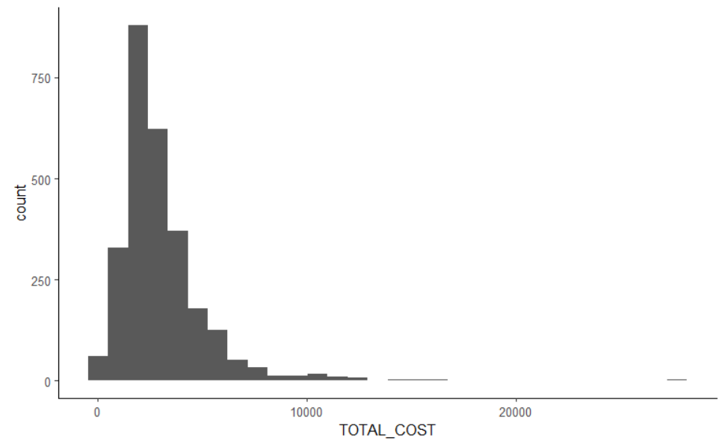
- The peak that corresponds to the total costs is clearly located between €1 000 and €5 000 (Histogram), whereas the data dispersion extends from €285 to €27 985 (around).
- The value of the minimum total costs is €285, whereas that of the maximum total costs is €27 985: A significant difference (€27 700) can be observed between the two values, the value of the maximum total costs is very high;
- The 1st Quartile of the total costs’ values is €1 738, in other words, 25% of the values of total costs are lower than or equal to €1 738;
- The 2nd Quartile (Median) of the total costs’ values is €2 508, in other words, 50% of the total costs’ values are lower than or equal to €2 508, and the remaining 50% are greater than or equal to €2 508;
- The 3rd Quartile of the total costs’ values is €3 718, in other words, 75% of the total costs’ values are lower than or equal to €3 718;
- The Average of the total costs’ values is €3 038 (outliers might be therefore present among the data), this value is greater than the Median which is €2 508: We therefore have an asymmetry to the right here.

Ages analysis (AGE)
Min. 1st Qu. Median Mean 3rd Qu. Max.
18.00 75.00 83.00 80.29 89.00 104.00
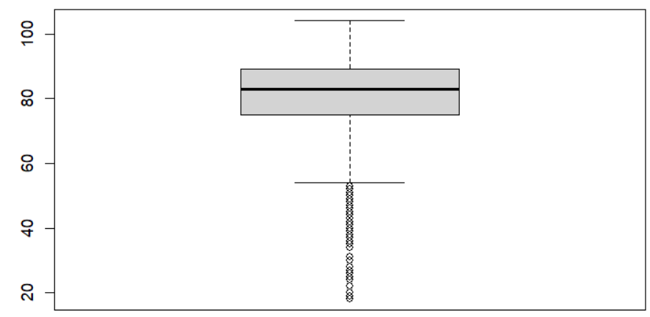
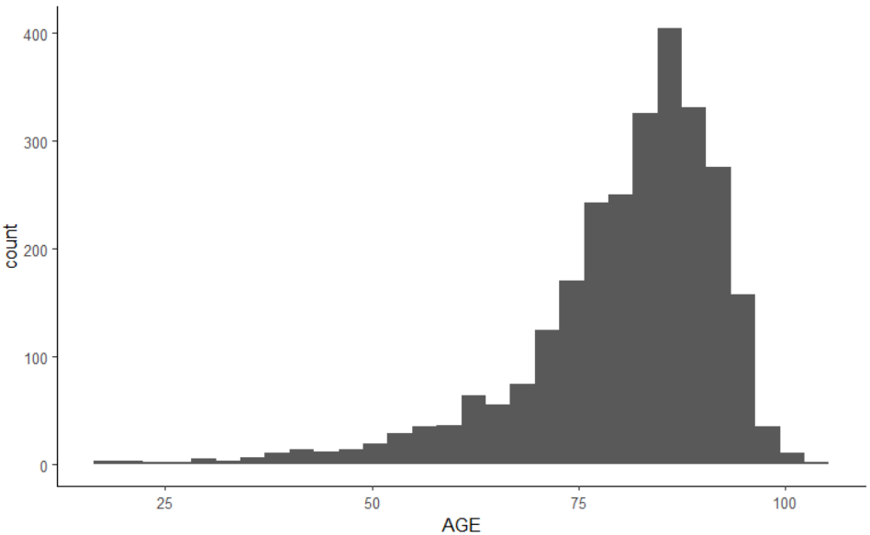
- The peak of data recorded on patients admitted ages is clearly situated between 80 years and 90 years (histogram), whereas the data dispersion extends from 15 years old to 105 years old (approximately);
- The minimum age is 18 years old, whereas the maximum one is 104 years old. A significant difference (86 years) can be deduced from these two values;
- The 1st Quartile of age values is 75 years old, in other words, 25% of the patients admitted are aged 75 years old or less;
- The 2nd Quartile (Median) of age values is 83 years old, in other words, 50% of the patients admitted are aged 83 years old or less, and the remaining 50% are at least aged 83 years old;
- The 3rd Quartile of the age values of the patients is 89 years old, in other words, 75% of the patients admitted are aged 89 years old or less;
- The Average of the age of the patients is 80,29 years old (outliers might therefore be present among the data), this value is lower than the Median which is 83 years old: We therefore have an asymmetry to the left here;
- The existence of values (below 60 years old) of outliers can be observed (Histogram & BoxPlot).

Diagnostic costs analysis (COST_DIAGNOSTIC)
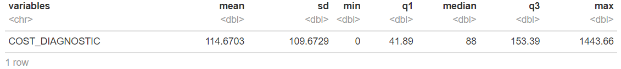
- The minimum cost is €0, whereas the maximum one is €1443.66 (a significant difference of € 1443,66);
- The 1st Quartile of the values of the diagnostic cost is €41.89, in other words, 25% of the values of diagnostic costs are lower than or equal to €41.89;
- The 2nd Quartile of the values of diagnostic costs is €88, in other words, 50% of the values of diagnostic cost are lower than or equal to €88, and the remaining 50% are greater than or equal to €88;
- The 3rd Quartile of the values of diagnostic cost is €153.39, in other words, 75% of the values of the diagnostic costs are lower than or equal to €153.39;
- The Average cost of diagnostic is €114.6703, a value that is greater than the Median which is €88: We therefore have an asymmetry to the right;
- The standard deviation is €109.6729, it is clearly high. We therefore deduce that the data on the values of diagnostic cost are dispersed and are situated far from the Average which is €114,6703 (Heterogeneous Data)

Lengths of stay, ages and total costs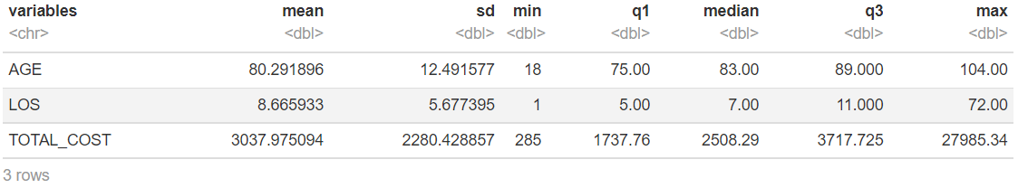
- From the values of their Standard Deviation which are all more or less high (respectively 12.49 years old, 5.68 days and €2 280.43), the data on the ages (I.13), on the lengths of stay within the Hospitals (I.11) and on the total costs are all dispersed and are situated far from their Average (respectively: 80.29 years old, 8.67 days and €3 037.98), we therefore have Heterogeneous Data here;
- Always based on these values of Standard Deviation, by sorting them in an ascending order, we can deduce that the data on the lengths of stay within the Hospitals are less heterogeneous than those one the ages, and these latter are less heterogeneous than those on the total costs.

Bivariate analysis

II.1- Analysis of the relationship existing between the Admission Ward and the DRG code
DRG_CODE
WARD_ADMISSION 087 089 090 127 576
08 71 1 2 140 5
21 64 83 14 155 61
24 0 21 15 1 97
2604 199 52 36 129 109
2605 566 37 16 163 351
68 266 40 27 3 3

Pourcentage en ligne
DRG_CODE
WARD_ADMISSION 087 089 090 127 576 Total
08 32.4 0.5 0.9 63.9 2.3 100.0
21 17.0 22.0 3.7 41.1 16.2 100.0
24 0.0 15.7 11.2 0.7 72.4 100.0
2604 37.9 9.9 6.9 24.6 20.8 100.0
2605 50.0 3.3 1.4 14.4 31.0 100.0
68 78.5 11.8 8.0 0.9 0.9 100.0
Ensemble 42.8 8.6 4.0 21.7 23.0 100.0

Pourcentage en colonne
DRG_CODE
WARD_ADMISSION 087 089 090 127 576 Ensemble
08 6.1 0.4 1.8 23.7 0.8 8.0
21 5.5 35.5 12.7 26.2 9.7 13.8
24 0.0 9.0 13.6 0.2 15.5 4.9
2604 17.1 22.2 32.7 21.8 17.4 19.3
2605 48.5 15.8 14.5 27.6 56.1 41.5
68 22.8 17.1 24.5 0.5 0.5 12.4
Total 100.0 100.0 100.0 100.0 100.0 100.0

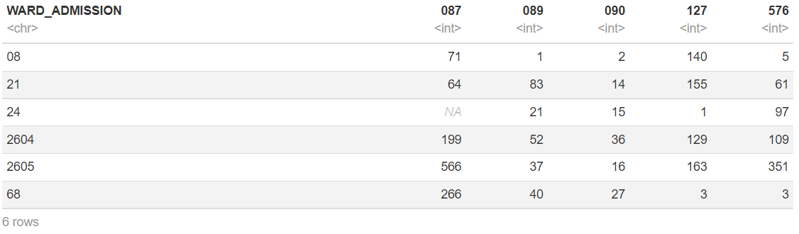
- The admission within a Ward depends on the corresponding DRG code, in other words, « WARD_ADMISSION » corresponds to the variable to be explained (dependent) whereas the « DRG_CODE » corresponds to the explanatory one (independent);
- From the data above, we can make the remarks:
- Patients with a DRG 087 « Pulmonary edema and respiratory failure » are mostly admitted within the Ward « General Medicine » (2605 in a large part), more than in Ward 68 «Respiratory Medicine » ;
- Patients with a DRG 089 « Pneumonia and pleuritis with complications » are mainly admitted within the Wards 21 « Geriatrics », 2604 « General Medicine 1 » & 2605 « General Medicine 2 », 68 «Respiratory Medicine » but rarely within the Ward 08 « Cardiology »;
- Patients with a DRG 090 « Pneumonia and pleuritis >17 year old » are more often admitted in Ward 2604 « General Medicine 1 » than in Ward 68 « Respiratory Medicine » ;
- Patients with a DRG 127 « Heart failure and shock » are mainly admitted in Wards 2605 « General Medicine 2 » & 2604 « General Medicine 1 », 21 « Geriatrics » or 08 but rarely in Wards 68 «Respiratory Medicine » or 24 « Infection and Immunology »;
- Patients with a DRG 576 « Sepsis without medical ventilation » are mostly admitted in Wards 2605 « General Medicine 2 » (in a large part) & 2604 « General Medicine 1 » than in Ward 24 « Infection and Immunology ».

II.2- Analysis of the relationship existing between the Admission Ward and the Death within/outside Hospitals

DEATH_INHOSP
WARD_ADMISSION 0 1
08 202 17
21 308 69
24 115 19
2604 453 72
2605 983 150
68 323 16

Pourcentage en ligne
DEATH_INHOSP
WARD_ADMISSION 0 1 Total
08 92.2 7.8 100.0
21 81.7 18.3 100.0
24 85.8 14.2 100.0
2604 86.3 13.7 100.0
2605 86.8 13.2 100.0
68 95.3 4.7 100.0
Ensemble 87.4 12.6 100.0

Pourcentage en colonne
DEATH_INHOSP
WARD_ADMISSION 0 1 Ensemble
08 8.5 5.0 8.0
21 12.9 20.1 13.8
24 4.8 5.5 4.9
2604 19.0 21.0 19.3
2605 41.2 43.7 41.5
68 13.5 4.7 12.4
Total 100.0 100.0 100.0

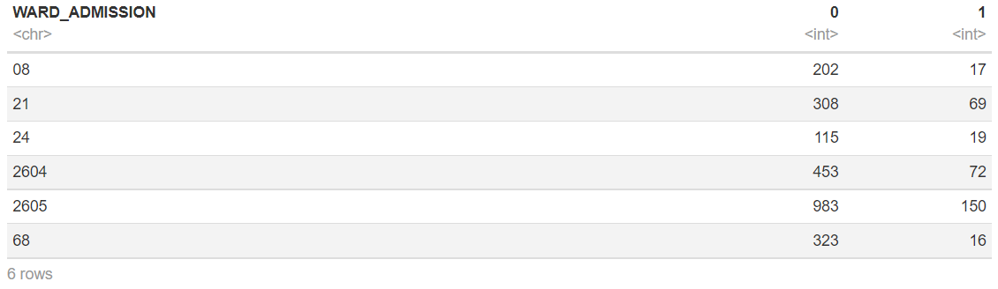
- The table on the Row Percentage provides data from which we can notice that the proportion of deaths occurring outside Hospitals or during the stays within the Hospitals depends on the Ward of Admission of the patient;
- From this table on the Row Percentage, we can notice that the proportions of deaths occurring outside the Hospitals for the patients that have been admitted within the Wards 08 and 68 tend to be higher than those within the other Wards, and that, logically, those of the deaths occurring within the Hospitals tend to be less high than within the other Wards.

II.3- Total Costs w.r.t the department
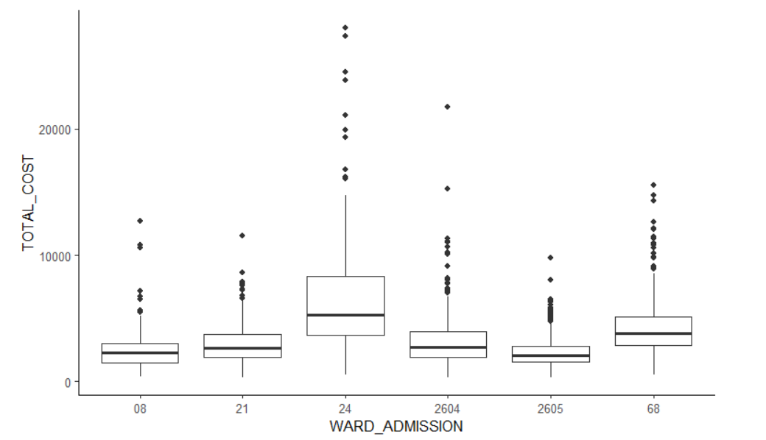
- Here, we can identify the « WARD_ADMISSION » as being the independent variable (explanatory variable) and the « TOTAL_COST » as the dependent one (to be explained from the WARD_ADMISSION);
- We can notice from those BoxPlots:
- The admissions in Ward 24 globally correspond to the highest total costs observed. With the most significant variability of costs, however less constant, we notice that the corresponding data are asymmetrical;
- After the admissions in Ward 24 come those in Ward 68 in terms of high costs, this time with a less significant variability and a better data constancy when it comes to the costs;
- The admissions within the other Wards correspond to total costs that are less significant, but the corresponding data are generally constant and relatively symmetrical compared to those which correspond to the ward 24.

II.4- Total Costs w.r.t the type of admission department (generalist VS specialist)
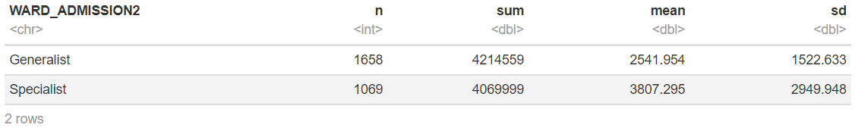
car::leveneTest(TOTAL_COST ~ WARD_ADMISSION2, df_WA_TTC)

Levene's Test for Homogeneity of Variance (center = median)
Df F value Pr(>F)
group 1 129.61 < 2.2e-16 ***
2725
---
Signif. codes: 0 ‘***’ 0.001 ‘**’ 0.01 ‘*’ 0.05 ‘.’ 0.1 ‘ ’ 1

- H0: The variances of the two groups « Generalist » and « Specialist » are equal.
wilcox.test(TOTAL_COST ~ WARD_ADMISSION2 , df_WA_TTC, conf.int = T)

Wilcoxon rank sum test with continuity correction

data: TOTAL_COST by WARD_ADMISSION2
W = 603617, p-value < 2.2e-16
alternative hypothesis: true location shift is not equal to 0
95 percent confidence interval:
-950.10 -718.36
sample estimates:
difference in location
-829.9

- There is a significant difference between the costs when the patients are directed to the generalist wards and when they are directed to the specialist ones.
df_WA_TTC %>%
filter(WARD_ADMISSION2 == 'Generalist') %>%
select(TOTAL_COST ) %>% unlist() %>% as.numeric() %>% shapiro.test()

Shapiro-Wilk normality test

data: .
W = 0.82541, p-value < 2.2e-16

- The costs distribution related to the admissions within the departments of the Generalist type doesn’t follow normal distribution.

df_WA_TTC %>%
filter(WARD_ADMISSION2 != 'Generalist') %>%
select(TOTAL_COST ) %>% unlist() %>% as.numeric() %>% shapiro.test()

Shapiro-Wilk normality test

data: .
W = 0.74452, p-value < 2.2e-16

- The costs distribution related to the admissions within the departments of the Specialist type doesn’t follow a normal distribution.

df_WA_TTC %>%
select(TOTAL_COST ) %>% unlist() %>% as.numeric() %>% shapiro.test()

Shapiro-Wilk normality test

data: .
W = 0.7264, p-value < 2.2e-16
- The distribution of the total costs doesn’t follow a normal distribution.

kruskal.TTC_WA<- kruskal.test(TOTAL_COST ~ WARD_ADMISSION, data = df_WA_TTC)
kruskal.TTC_WA
Kruskal-Wallis rank sum test

data: TOTAL_COST by WARD_ADMISSION
Kruskal-Wallis chi-squared = 522.87, df = 5, p-value < 2.2e-16

- The total costs within each department of admissions aren’t identical populations
pairwise.wilcox.test(df_WA_TTC$TOTAL_COST, df_WA_TTC$WARD_ADMISSION,p.adjust.method = "BH")

Pairwise comparisons using Wilcoxon rank sum test with continuity correction

data: df_WA_TTC$TOTAL_COST and df_WA_TTC$WARD_ADMISSION

08 21 24 2604 2605
21 3.1e-05 - - - -
24 < 2e-16 < 2e-16 - - -
2604 1.3e-06 0.38 < 2e-16 - -
2605 0.33 3.0e-15 < 2e-16 < 2e-16 -
68 < 2e-16 < 2e-16 2.9e-09 < 2e-16 < 2e-16

P value adjustment method: BH
- We have noticed a significant difference of costs between:
- department 08 vs department 21 ;
- department 08 vs department 24 ;
- department 08 vs department 2604 ;
- department 08 vs department 68 ;
- department 21 vs department 24 ;
- department 21 vs department 2605 ;
- department 24 vs department 2604 ;
- department 24 vs department 2605 ;
- department 24 vs department 68 ;
- department 2604 vs department 2605 ;
- department 2604 vs department 68 ;
- department 2605 vs department 68 ;

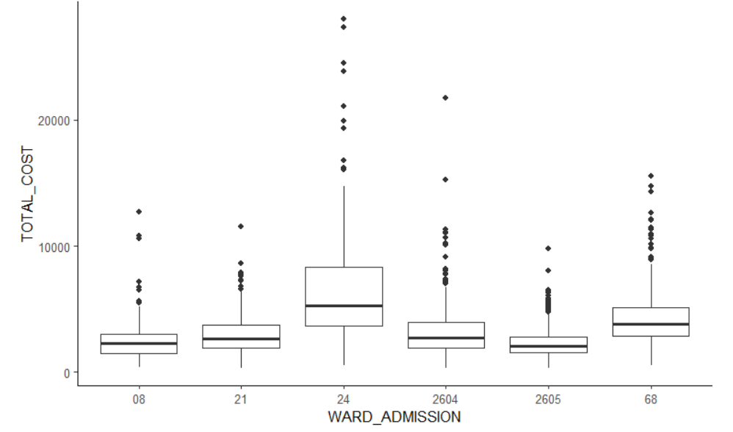

II.5- Hospital cost of a patient within the department (per day) (in Euros) w.r.t department of admission
COST_DAY_WARD
WARD_ADMISSION 285 313 363 463 481
08 0 0 219 0 0
21 0 377 0 0 0
24 0 0 0 0 134
2604 525 0 0 0 0
2605 1133 0 0 0 0
68 0 0 0 339 0

- We can obviously understand that :
- The costs at €285 concern only the Wards « General Medicine » : Mostly for the Ward 2605, and a smaller part for the Ward 2604;
- The costs at €313 concern only the Ward 21;
- The costs at €363 concern only the Ward 08;
- The costs at €463 concern only the Word 68;
- The costs at €481 concern only the Ward 24.

II.6- Total Costs distribution w.r.t the Admission Ward (Generalist and Specialist) and the DRG code
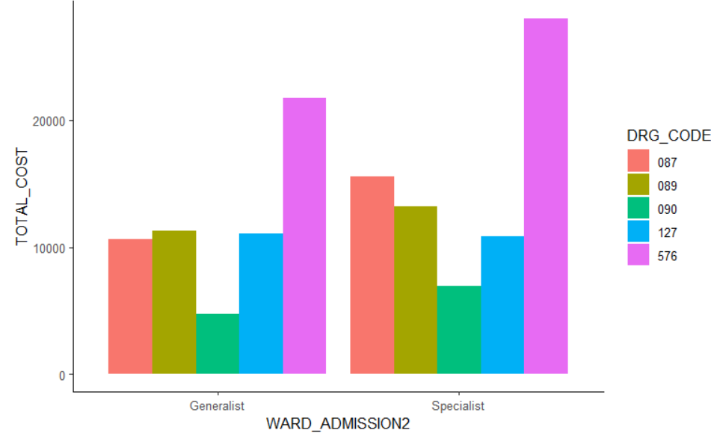
- The peaks of values of the set of Total Costs both correspond to the admissions with a DRG 376 within the two groups of admissions regarding the type of ward, but the peak is clearly more significant for the admissions within the Specialist Wards than within the Generalist ones;
- If the Total Costs seem to be as high for the admissions in the Generalist Wards as for those in the Specialist ones when it comes to the admissions with a DRG 127, they are less significant for the admissions within the Specialist Wards than those within the Generalist ones when it comes to the DRG 090;
- However, Total Costs are less high for the admissions within the Generalist Wards than those within the Specialist Wards when it comes to the admissions with a DERG 089 or 087.

II.7- Death within/outside Hospitals distribution w.r.t the Ward of Admission (Generalist vs Specialist) and the DRG Code
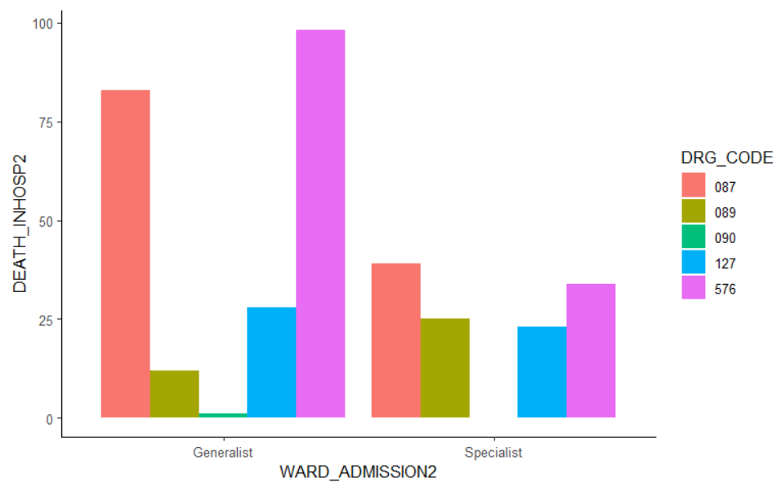

- The number of deaths occurred within Hospitals and linked to a DRG 576 constitutes the peaks for the case of the Generalist Wards, which is not the case for its counterpart in the Specialist Wards, largely less significant;
- Although it is largely less significant than that of the Generalist Wards, the number of deaths occurred within Hospitals and linked to DRG 087 constitutes a timid peak for the case of the Specialist Wards;
- The number of deaths occurred within Hospitals and linked to a DRG 089 within the Specialist Wards is greater than that of the Generalist ones, whereas for those linked to a DRG 127, the situation is reversed;
- Deaths occurred within Hospitals and linked to a DRG 090 are relatively rare for the Generalist Wards and almost non-existent for the case of the Specialist ones.

II.8- Risk of Death within/outside Hospitals distribution w.r.t the Ward of Admission
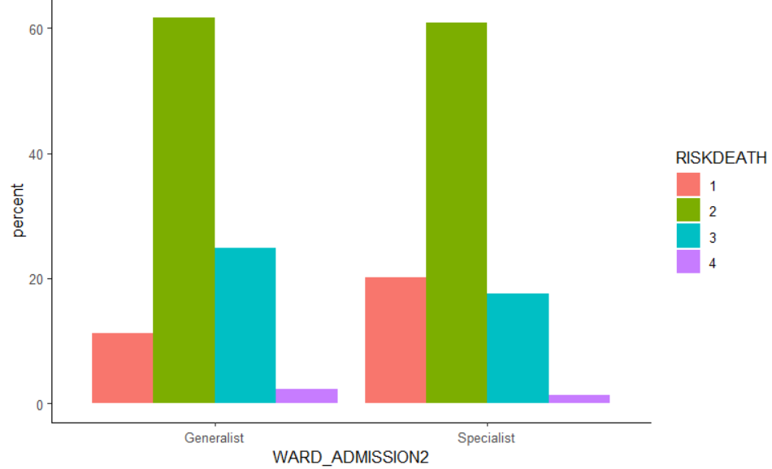

- The proportions of admissions with a level 2 of RISKDEATH constitute the peaks (peaks that are relatively similar) respectively corresponding to the Generalist and Specialist Wards (behavior found after re-decomposing the groups of wards);
- Admissions with a level 1 of RISKDEATH are more frequent within the Specialist Wards than within the Generalist ones, whereas for the case of the admissions with a level 3 of RISKDEATH, the situation is reversed;
- Admissions with a level 4 of RISKDEATH are relatively infrequent, whether within the Generalist Wards or the Specialist ones.
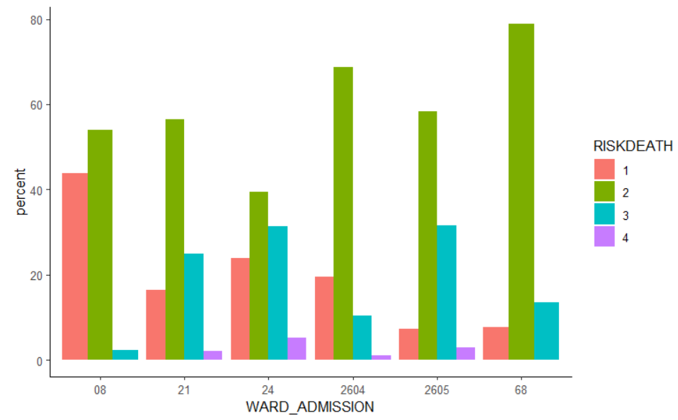
- Les pics d’admissions avec un RISKDEATH de niveau 2 des groupes Generalist et Specialist sont retrouvés après re-décomposition de ces derniers.
- Les admissions avec un RISKDEATH de niveau 1 sont particulièrement plus fréquentes pour le cas du Ward 08, en contrepartie, celles avec un RISKDEATH de niveau 3 sont particulièrement peu fréquentes.
- Les admissions avec un RISKDEATH de niveau 4 sont plutôt rares, seulement constatés en très petites proportions aux niveaux des Wards 21, 24, 2604 et 2605.
- Les admissions avec un RISKDEATH de niveau 3 sont plus ou moins fréquentes dans chaque Ward, le Ward 08 faisant une petite exception à ce comportement avec notamment ce type d’admission qui est particulièrement peu constaté pour son cas.

II.9- Ages distribution w.r.t the Risk of Death
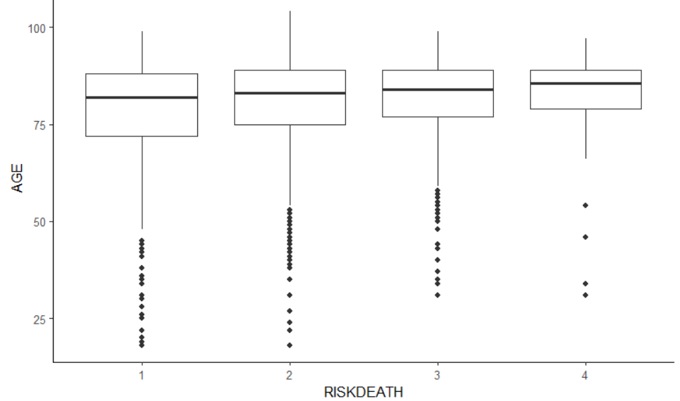
- From these BoxPLots, we can notice :
- Very clearly, RISKDEATHs concern mainly the older patients (more than 70 years old), with however a few outliers for each BoxPlot;
- The 4 BoxPlots are relatively at the same level of age, have relatively the same values of Median, but their distributions are slightly different in function of the levels of RISKDEATH;
- By starting our reading from the level 1 to the level 4 on the axis dedicated to the RISKDEATH, we clearly observe that the variability of the data on the ages continually decrease, as well as the quantities of outliers (the most important RISKDEATHs concern mostly the older patients) .

df_AGE_RISKDEATH <- df %>%
select(AGE, RISKDEATH) %>%
mutate(RISKDEATH = as.character(RISKDEATH) )

car::leveneTest(AGE ~ RISKDEATH, df_AGE_RISKDEATH)

Levene's Test for Homogeneity of Variance (center = median)
Df F value Pr(>F)
group 3 13.696 7.253e-09 ***
2723
---
Signif. codes: 0 ‘***’ 0.001 ‘**’ 0.01 ‘*’ 0.05 ‘.’ 0.1 ‘ ’ 1

- H0 : Variances are equal

aov.RiskDeathAge <- aov(AGE ~ RISKDEATH, data = df_AGE_RISKDEATH)
summary(aov.RiskDeathAge)

Df Sum Sq Mean Sq F value Pr(>F)
RISKDEATH 3 6019 2006 13.03 1.9e-08 ***
Residuals 2723 419345 154
---
Signif. codes: 0 ‘***’ 0.001 ‘**’ 0.01 ‘*’ 0.05 ‘.’ 0.1 ‘ ’ 1

shapiro.test(x = residuals(object = aov.RiskDeathAge ))

Shapiro-Wilk normality test

data: residuals(object = aov.RiskDeathAge)
W = 0.89206, p-value < 2.2e-16

kruskal.RiskDeathAge <- kruskal.test(AGE ~ RISKDEATH, data = df_AGE_RISKDEATH)
kruskal.RiskDeathAge

Kruskal-Wallis rank sum test

data: AGE by RISKDEATH
Kruskal-Wallis chi-squared = 17.433, df = 3, p-value = 0.0005756

pairwise.wilcox.test(df_AGE_RISKDEATH$AGE, df_AGE_RISKDEATH$RISKDEATH,p.adjust.method = "BH")

Pairwise comparisons using Wilcoxon rank sum test with continuity correction

data: df_AGE_RISKDEATH$AGE and df_AGE_RISKDEATH$RISKDEATH

1 2 3
2 0.04798 - -
3 0.00063 0.01487 -
4 0.08924 0.29624 0.78815

P value adjustment method: BH

- There is a difference of the age between :
- Level 1 of RISKDEATH vs Level 2 of RISKDEATH ;
- Level 1 of RISKDEATH vs Level 3 of RISKDEATH ;
- Level 2 of RISKDEATH vs Level 3 of RISKDEATH.

II.10- Ages Distribution in function of Total Costs

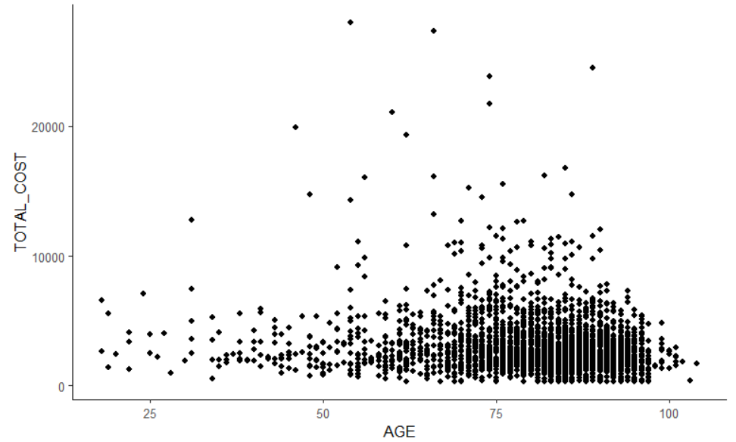

- We can observe that the Total Costs mainly concern elderly patients, an less the younger ones;
- However, we notice that the relationship tends to be negative between the TOTAL_COST and the AGE when it comes to the highest costs, these latters concern the most the patients admittedly the elderly ones (i.e. >60 years old), but at the same time not among the oldest ones (i.e. <90 years old), and constitute a significant proportion of the patients.

II.11- Distribution des coûts totaux selon des durées de séjour

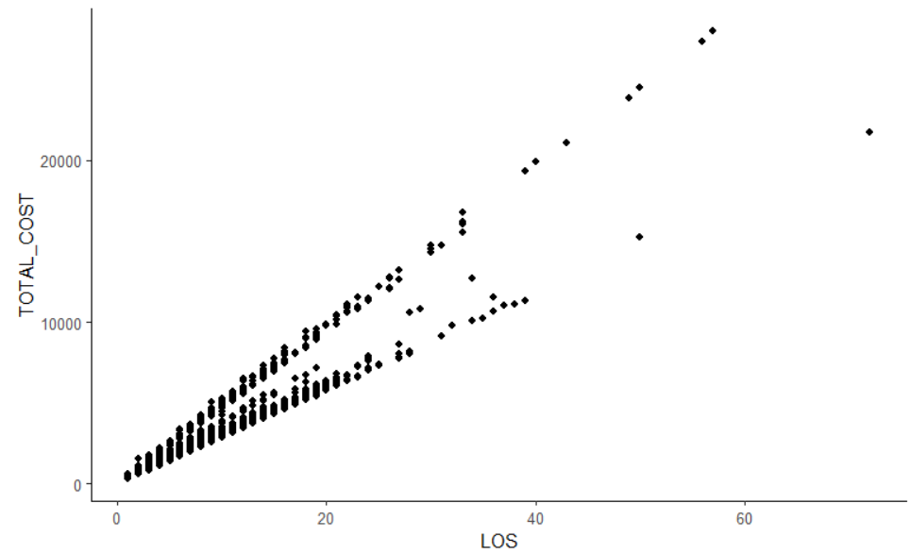
- Nous pouvons remarquer que la relation existante entre le LOS et TOTAL_COST est Positive.
- Plus le temps de séjour est élevé, plus les coûts totaux, eux aussi, sont élevés (ce qui bien logique).

II.12- Distribution des coûts totaux selon l’âge

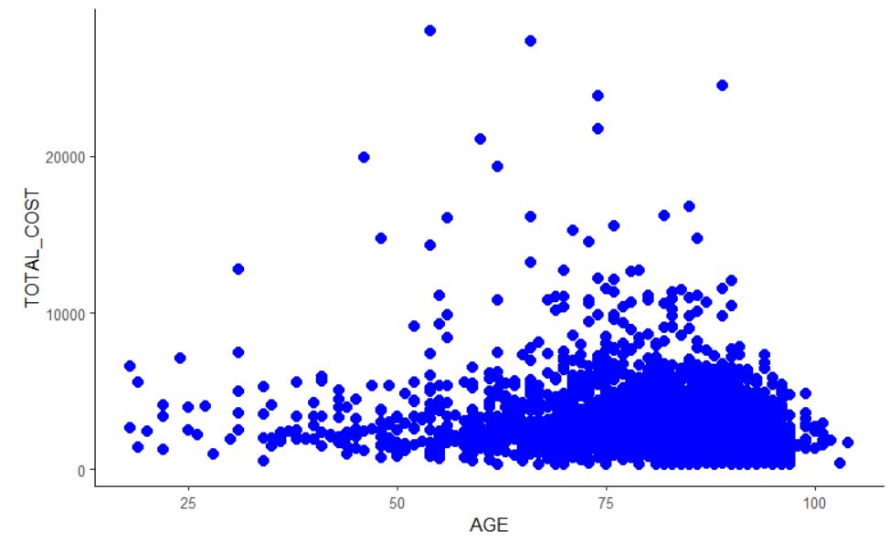
- Nous pouvons remarquer que les patients âgés sont les plus concernés par les coûts totaux que les plus jeunes.
- Cependant, on remarque que la relation tend à être plutôt négative entre le AGE et les TOTAL_COST : les patients âgés mais ne faisant pas non plus partie de ceux des plus âgés (soit principalement les sexagénaires, septuagénaires et une partie des octogénaires) sont les principaux concernés par les coûts totaux les plus élevés.

II.13- Distribution des coûts totaux selon les risques de décès
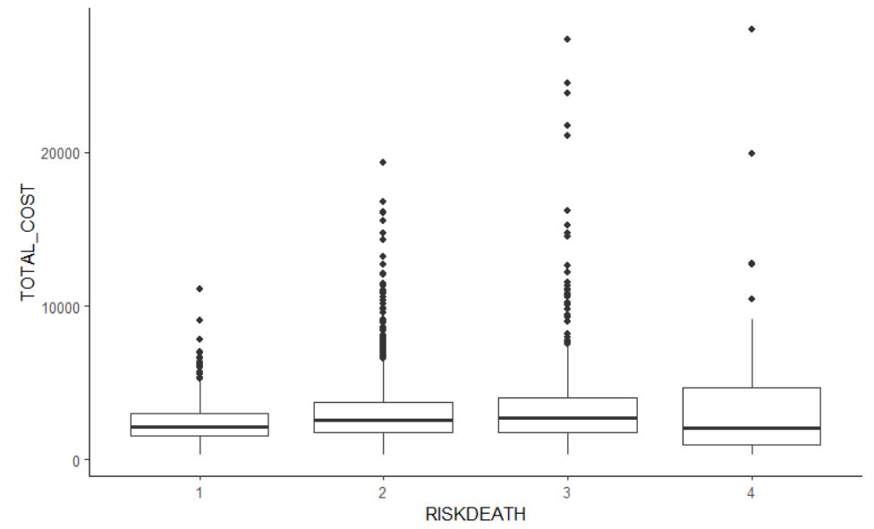
- A partir de ces BoxPlots, nous pouvons remarquer :
- Les 4 Boxplots se trouvent relativement au même niveau (de TOTAL_COST), ont relativement les même valeurs de mediane, mais avec des distributions de données légèrement différentes en fonction des niveaux de RISKDEATH 1, 2 et 3, et une plus grande variabilité des données est constatée pour le niveau de RISKDEATH 4 ;
- En commençant notre lecture du niveau 1 jusqu’au niveau 4 sur l’axe consacré au RISKDEATH, on constate clairement que la variabilité des données sur les TOTAL_COST augmentent continuellement.
- Les données sur les coûts totaux aberrantes sont plus importantes pour les niveaux de RISK_DEATH 2 et 3, et moins importantes pour les niveaux 1 et 4.
car::leveneTest(TOTAL_COST ~ RISKDEATH, df_TTC_RISKDEATH)
Levene's Test for Homogeneity of Variance (center = median)
Df F value Pr(>F)
group 3 24.35 1.515e-15 ***
2723
---
Signif. codes: 0 ‘***’ 0.001 ‘**’ 0.01 ‘*’ 0.05 ‘.’ 0.1 ‘ ’ 1

- Egalité de variance vérifiée

kruskal.RiskDeathTTC <- kruskal.test(TOTAL_COST ~ RISKDEATH, data = df_TTC_RISKDEATH)
kruskal.RiskDeathTTC

Kruskal-Wallis rank sum test

data: TOTAL_COST by RISKDEATH
Kruskal-Wallis chi-squared = 37.997, df = 3, p-value = 2.831e-08

- Il y a une différence des coûts totaux selon les risques de décès.

pairwise.wilcox.test(df_TTC_RISKDEATH$TOTAL_COST, df_TTC_RISKDEATH$RISKDEATH,p.adjust.method = "BH")

Pairwise comparisons using Wilcoxon rank sum test with continuity correction

data: df_TTC_RISKDEATH$TOTAL_COST and df_TTC_RISKDEATH$RISKDEATH

1 2 3
2 1.8e-07 - -
3 2.1e-07 0.18 -
4 0.71 0.16 0.16

P value adjustment method: BH

- Nous constatons une différence de coût entre :
- Risque de décès 1 vs Risque de décès 2 ;
- Risque de décès 1 vs Risque de décès 3.

II.14- Distribution des coûts totaux selon l’indice CCI

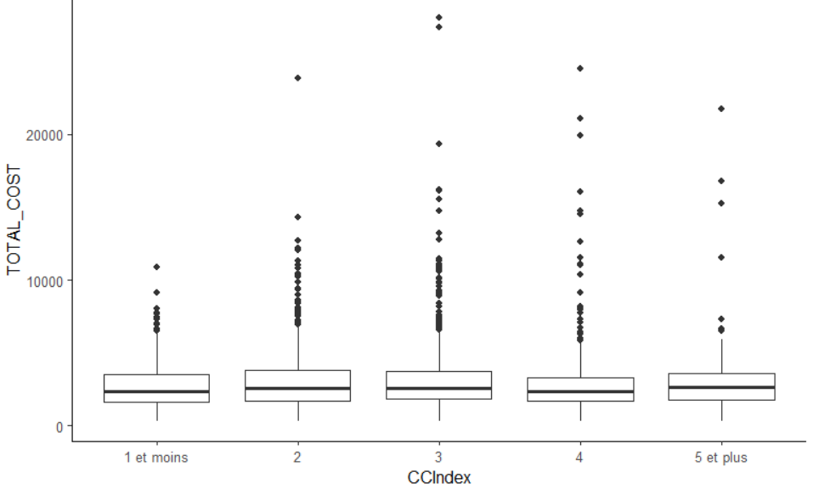
- A partir de ces BoxPlots, nous pouvons remarquer :
- Les 5 Boxplots se trouvent relativement au même niveau (de TOTAL_COST), ont relativement les même valeurs de médiane de coûts totaux, et ont des distributions de données sur les coûts totaux légèrement différentes en fonction des index de CCI.
- Les données sur les coûts totaux aberrantes (élevés) sont plus importantes pour les index de CCI 2, 3 et 4, et relativement moins importantes pour les index de CCI « 1 et moins » et « 5 et plus ».
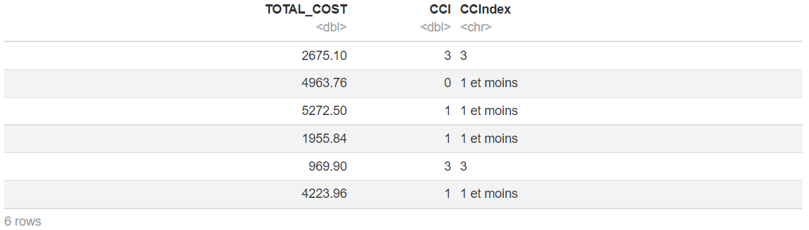
car::leveneTest(TOTAL_COST ~ CCIndex, df_TTC_CCI)
Levene's Test for Homogeneity of Variance (center = median)
Df F value Pr(>F)
group 4 1.7774 0.1305
2722

aov.CCITTC <- aov(TOTAL_COST ~ CCIndex, data = df_TTC_CCI)
summary(aov.CCITTC)

Df Sum Sq Mean Sq F value Pr(>F)

CCIndex 4 7.434e+07 18585200 3.587 0.00635 **
Residuals 2722 1.410e+10 5180687
---
Signif. codes: 0 ‘***’ 0.001 ‘**’ 0.01 ‘*’ 0.05 ‘.’ 0.1 ‘ ’ 1

shapiro.test(x = residuals(object = aov.CCITTC ) )
Shapiro-Wilk normality test

data: residuals(object = aov.CCITTC)
W = 0.73005, p-value < 2.2e-16

kruskal.CCITTC <- kruskal.test(TOTAL_COST ~ CCIndex, data = df_TTC_CCI)
kruskal.CCITTC

Kruskal-Wallis rank sum test

data: TOTAL_COST by CCIndex
Kruskal-Wallis chi-squared = 9.0362, df = 4, p-value = 0.0602

- Il n’y a pas de différence significative du coût selon CCI.

II.15- Distribution des coûts totaux selon la sévérité
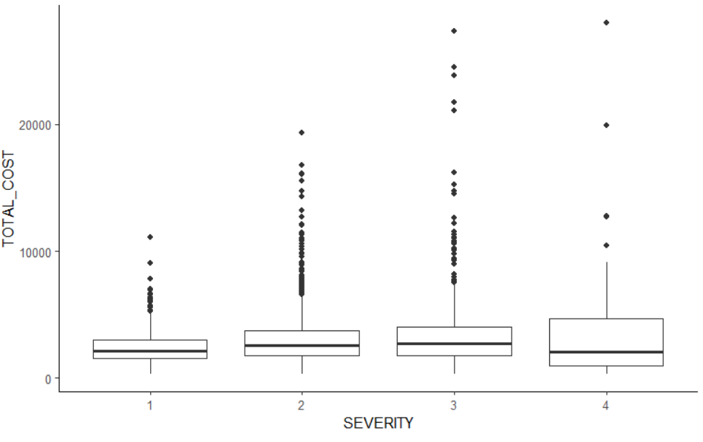
- A partir de ces BoxPlots, nous pouvons remarquer :
- Les 4 Boxplots ont relativement les même valeurs de mediane de TOTAL_COST, mais avec des distributions de données légèrement différentes en fonction des indices 1, 2 et 3, et des coûts totaux particulièrement plus élevés ainsi qu’ une plus grande variabilité des données sont constatés pour ce qui est du cas de l’indice 4 ;
- En commençant notre lecture de l’indice 1 jusqu’au niveau 3 sur l’axe consacré au SEVERITY, on constate clairement que la variabilité des données sur les TOTAL_COST augmentent légèrement et continuellement, tandis que l’augmentation de la variabilité est plutôt brusque comparée aux précédentes pour le cas du Boxplot correspondant à l’indice de SEVERITY 4.
- Les données sur les coûts totaux aberrantes sont plus importantes pour les indices de SEVERITY 2 et 3, mais moins importantes pour les niveaux 1 et 4 (par contre plus dispersées pour le cas de ce dernier).
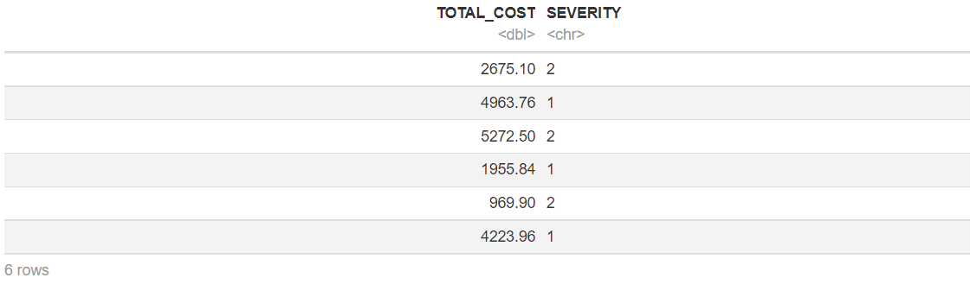
car::leveneTest(TOTAL_COST ~ SEVERITY, df_TTC_SEV)

Levene's Test for Homogeneity of Variance (center = median)
Df F value Pr(>F)
group 3 24.35 1.515e-15 ***
2723
---
Signif. codes: 0 ‘***’ 0.001 ‘**’ 0.01 ‘*’ 0.05 ‘.’ 0.1 ‘ ’ 1

- Egalité de variance vérifiée.

kruskal.SEVTTC <- kruskal.test(TOTAL_COST ~ SEVERITY, data = df_TTC_SEV)
kruskal.SEVTTC

Kruskal-Wallis rank sum test

data: TOTAL_COST by SEVERITY
Kruskal-Wallis chi-squared = 37.997, df = 3, p-value = 2.831e-08

- Nous constatons une différence du coût selon la sévérité.

pairwise.wilcox.test(df_TTC_SEV$TOTAL_COST, df_TTC_SEV$SEVERITY,p.adjust.method = "BH")

Pairwise comparisons using Wilcoxon rank sum test with continuity correction

data: df_TTC_SEV$TOTAL_COST and df_TTC_SEV$SEVERITY

1 2 3
2 1.8e-07 - -
3 2.1e-07 0.18 -
4 0.71 0.16 0.16

P value adjustment method: BH

- Il y a une difference de coût entre :
- Séverité 1 vs Séverité 2 ;
- Séverité 1 vs Séverité 3.

II.16- Distribution des âges selon la sévérité

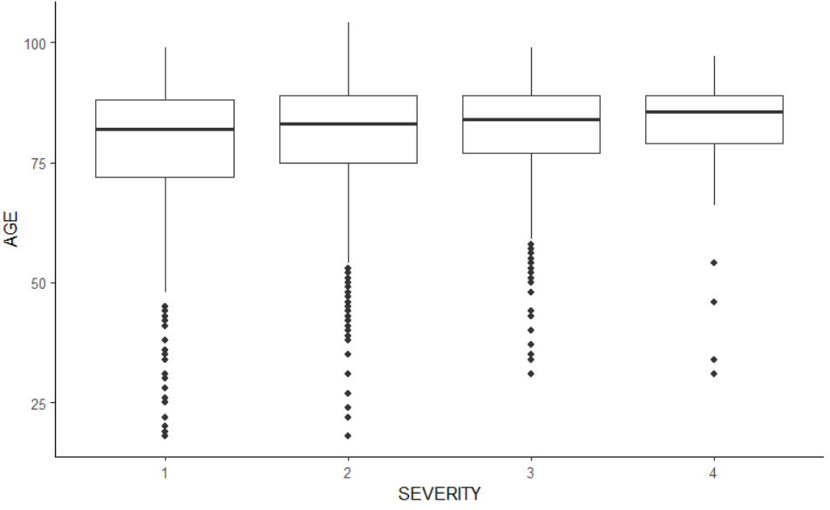
- A partir de ces BoxPlots, nous pouvons remarquer :
- Très clairement, les SEVERITY concernent principalement les patients âgées (70 ans et plus), avec néanmoins quelques donnés aberrantes sur les âges pour chaque Boxplot.
- Les 4 Boxplots se trouvent relativement au même niveau (d’âge), ont relativement les même valeurs de médiane d’âge, mais avec des distributions différentes en fonction de l’indice de sévérité;
- En commençant notre lecture de l’indice de SEVERITY 1 jusqu’à celui du 4 sur l’axe consacré au SEVERITY, on constate clairement que la variabilité des données sur les âges diminuent continuellement, ainsi que les quantités de données aberrantes (les indices plus élevés de SEVERITY concernent le plus les patients âgées que les plus jeunes).
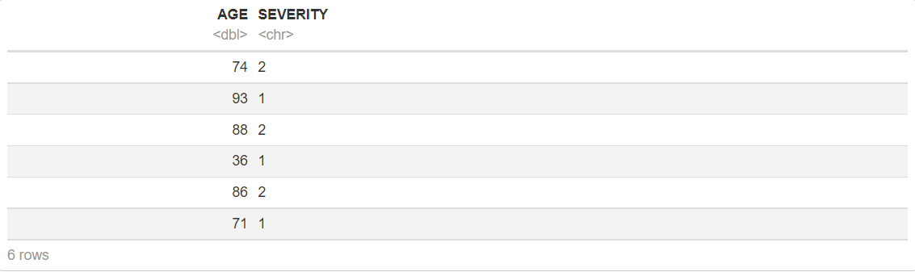
car::leveneTest(AGE ~ SEVERITY, df_AGE_SEV)
Levene's Test for Homogeneity of Variance (center = median)
Df F value Pr(>F)
group 3 13.696 7.253e-09 ***
2723
---
Signif. codes: 0 ‘***’ 0.001 ‘**’ 0.01 ‘*’ 0.05 ‘.’ 0.1 ‘ ’ 1

- Egalité de variance vérifiée.

kruskal.SEVAGE <- kruskal.test(AGE ~ SEVERITY, data = df_AGE_SEV)
kruskal.SEVAGE

Kruskal-Wallis rank sum test

data: AGE by SEVERITY
Kruskal-Wallis chi-squared = 17.433, df = 3, p-value = 0.0005756

- Il y a une différence de l’âge selon la sévérité.

pairwise.wilcox.test(df_AGE_SEV$AGE, df_AGE_SEV$SEVERITY,p.adjust.method = "BH")

Pairwise comparisons using Wilcoxon rank sum test with continuity correction

data: df_AGE_SEV$AGE and df_AGE_SEV$SEVERITY

1 2 3
2 0.04798 - -
3 0.00063 0.01487 -
4 0.08924 0.29624 0.78815

P value adjustment method: BH

- Il y a une différence de AGE entre:
- Sévérité 1 vs Sévérité 2 ;
- Sévérité 2 vs Sévérité 3 ;
- Sévérité 1 vs Sévérité 2.

II.17- Corrélations des variables quantitatives (Correlation forte entre durées de séjours et coûts totaux)
cor.test(df$LOS, df$TOTAL_COST)

Pearson's product-moment correlation

data: df$LOS and df$TOTAL_COST
t = 133.1, df = 2725, p-value < 2.2e-16
alternative hypothesis: true correlation is not equal to 0
95 percent confidence interval:
0.9257757 0.9357958
sample estimates:
cor
0.9309608

df_corr_quantVar <- df %>%
select(TOTAL_COST, starts_with("COST_"), AGE, LOS) %>%
cor(., method = 'kendall')
ggcorrplot(df_corr_quantVar)
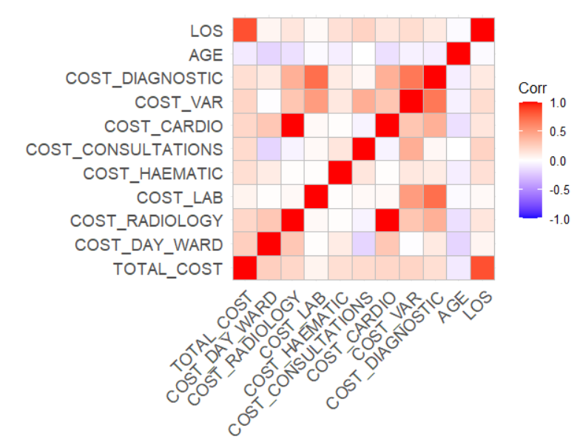
df_pmat <- df %>%
select(TOTAL_COST, starts_with("COST_"), AGE, LOS) %>%
ggcorrplot::cor_pmat(., method = 'kendall')
ggcorrplot(df_pmat)
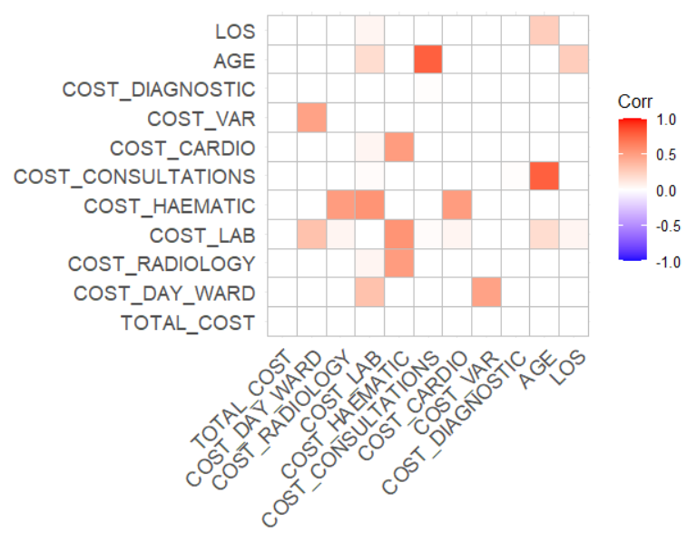
df %>%
select(TOTAL_COST, starts_with("COST_"), AGE, LOS) -> df_For_Corr
GGally::ggcorr(df_For_Corr, method = c("everything", "kendall"), nbreaks = 6)
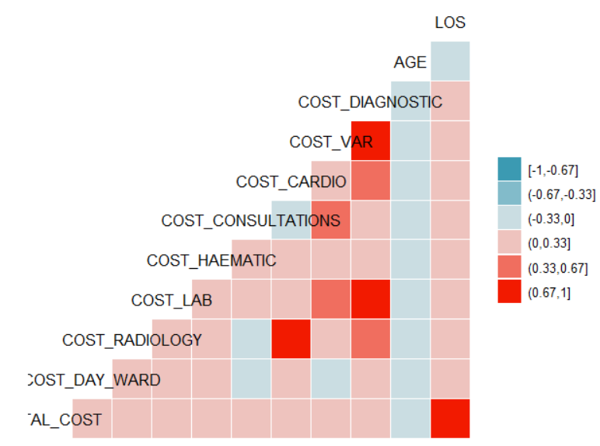
PerformanceAnalytics::chart.Correlation(df_For_Corr, histogram = TRUE, method = "pearson" ,pch = 19)
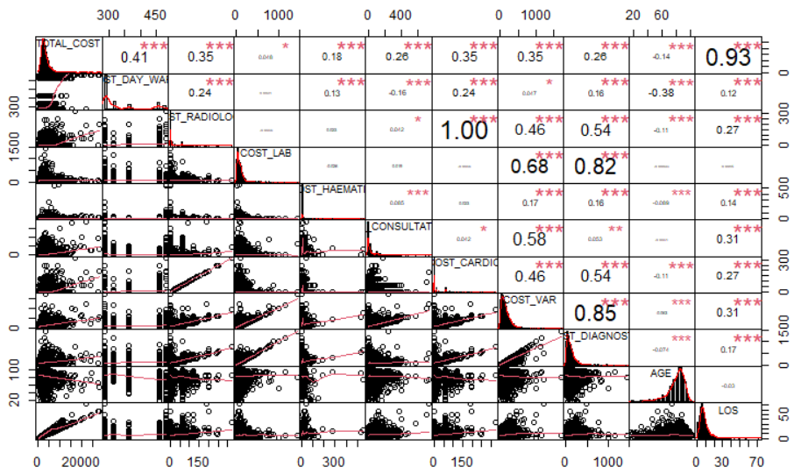
- Coefficient de corrélation entre LOS et TOTAL_COST égale à 0.93, très proche de 1.
- La corrélation entre LOS et TOTAL_COST est donc Forte.

